

The other day, I received a copy of Wagging Tales in the mail. Before actually reading it, I had little to no expectations for the book. It looked like it could be any other well-intentioned, perhaps too precious book about animals. But upon reading the word “telepathic” on the jacket cover, I realized this wasn’t your average book about pets. I was intrigued.

Author Tim Link is a professional animal communicator (as well as a Reiki energy healer). Wagging Tales is a compilation of his experiences communicating with various animals, since he uncovered his telepathic ability in 2004. While I’m definitely not new agey or spiritual, this stuff — holistic healing, intuitive communication, and the like — is something that fascinates me (yes, I’ve spoken with an animal communicator before). I decided to give the book a read and was glad I did. Wagging Tales turned out to be a fun, fast read. Within its 203 pages, Tim tells stories of how he helps people locate lost pets, assists animals adjust in their surroundings, tries to alleviate tensions between animals who are not getting along, and even speaks with a praying mantis. In between tales, Link gives helpful hints and factoids for pet owners that correlate to how you can prevent losing your animal (safe options on giving your cat outdoor time and micro chipping your pet), relieve tension between pets (giving pets separate toys, bowls, etc.), and other issues or problems you may encounter.
Wagging Tales came to be because his wife encouraged him to write about his amazing work. Luckily, from the beginning of his professional career, Tim kept journals of his experiences, so all of the stories were right there, ripe for the picking. He chose stories that give a flavor for his work, which mostly fall into three categories:
- Behavior change in animal (whether it be physical, emotional, mental)
- Lost pets
- Animals who have passed away or are about to. Tim provides grief counseling by letting the pet owner know what the animal’s wishes are before they pass on.
Something I found interesting is that Tim included some stories that weren’t necessarily “happy ending” types; although Tim has always able to connect with an animal, sometimes a tidy resolution wasn’t found. Tim included these experiences to represent reality, that the process is not necessarily so simple. Animals are individuals with complex feelings and needs. In fact, another aspect of the book that I found interesting was when he communicated with animals who expressed sentiments that seemed very human, such as when a cat named Angel kept wanting to talk to Tim about her tail (“She then went on to show me her beautiful black tail. She kept repeating ‘Beauty, beauty, beauty.’ This was to making sure that everyone knew she was beautiful and her tail was her best feature.”).
Tim first started working with conventional household pets, like dogs and cats, but has also worked with horses, snakes, spiders, etc. He’s worked with rescue shelters, zoos, aquariums, and wildlife sanctuaries, to help people understand the animals in their care, and to comfort and explain situations to the animals. Notable animal professional, Jack Hanna, has even worked with Tim. I found it surprising (but kinda cool, too!) that these people with science backgrounds, like veterinarians, zoologists, and the like, were open to a more holistic means of dealing with animals. Tim admits that not everyone is so keen on his methods, but that he’s worked with many different professionals, some more willing to openly admit their belief in his work than others.
Whether or not you’re a believer in telepathic or intuitive communication between humans and animals, I’m pretty sure that most of us who live with pets believe we can communicate with them in some way or the other. Tim believes that we do and can communicate with our animals telepathically. He says that all humans are born with intuitive powers, but that we learn to suppress the gift at an early age when talking becomes our sole means of communicating. People, like Tim, who are trained, can learn how to regain this ability. I’m not sure I’ve ever had any psychic abilities, but I definitely have a keen interest in being able to become closer to animals. After finishing the book, I asked Tim if he’d be interested in helping me communicate with P. Kitty and Biggie Smalls and to tell me more about his ability. He agreed to a telephone consultation (the main way he works with his clients), and asked me to send him the names and photos of my cats prior to our phone call. From what I understand, this helps an intuitive focus on the energy of the individual they’re trying to tap into.
Our phone call ended up getting postponed by about an hour because Tim was finishing up a last minute consultation with a school teacher whose dog had been missing for about a month. The session was taking a longer time then he expected. Tim was able to confirm that the dog was still alive, but he noted, the longer a pet is missing, the harder it is to connect with them (animals become too preoccupied with survival to be available). Yet, during the consultation, through map dowsing, a technique using a pendulum and a map, Tim was able to narrow down the dog’s energy to an area. Sometimes he’s able to specify an exact location, but usually he can narrow it down to a neighborhood, within a one mile radius.
When Tim called me and explained why he had to move our call back, I felt a little silly because I don’t actually have any real problems with my cats. I’m just curious about Tim’s line of work, but luckily, he didn’t seem to mind and was happy to oblige.
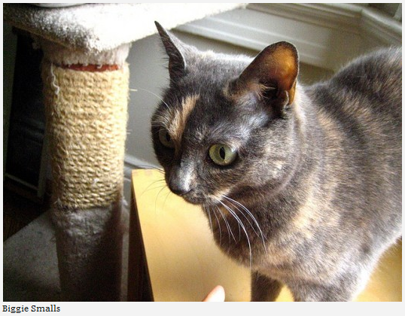
We started with Biggie, my skittish, but gentle kitty. I worry sometimes that Biggie’s fear impedes her from getting the attention she seems to crave. She will often lie on her back, expose her belly, and stare at you like she wants a belly rub, but as soon as you approach her to pet her, she’ll run away. What’s up with that? Tim explained that he was going to connect with Biggie, and that once he established the connection, he would works as a conduit between her and me. I said OK and waited for my cue to start asking questions. Tim got quiet on the line, as if he had just dialed a number into a phone and was waiting for someone on the other line to pick up. Suddenly I heard Tim softly chuckle and say “Aw.” I could almost hear him smile as he connected with Biggie, like the reaction people have when seeing a child doing something adorable. According to Tim, Biggie is not actually “skittish” or afraid, but mostly “unsure,” a word he says she kept using. She (like most animals) wants things to stay the same; changes to her environment are what make her most insecure. Biggie isn’t unhappy, but she has a feeling that something is about to change, which makes her tense. Is it possible, I wondered, that Biggie knows that Tim (my bf, that is) and I are about to leave for a trip to Ohio in a couple of weeks? Tim Link said yes, most certainly she knows, and suggested that verbally reassuring Biggie will help alleviate her insecurity.
Tim is a big proponent of talking out loud to animals. He says that not only do animals often understand the words you’re saying, but that by speaking out loud, the animals can decipher the energy you’re putting out when you’re expressing your thoughts. When you talk about things out loud, your energy goes up to a higher state, and animals relate to positive, higher energy. That’s why when talking to your pets you should always give them encouragement and positive reinforcement. Instead of telling them “don’t” or “no,” give them an alternative positive affirmation or suggestion. He also suggests to be specific and explain things like where you are going, when you’ll be back, and what a pet should do and why, which can help reassure and give purpose to a pet.
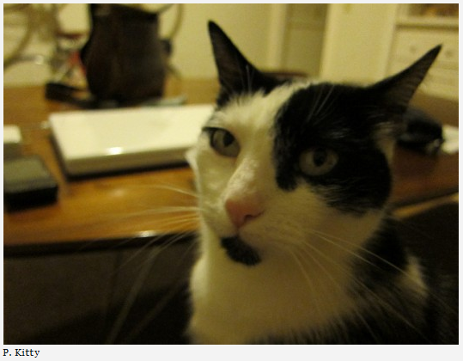
Next, Tim connected with P. Kitty. When he established a connection I heard him quietly exclaim “Wow!” Her energy, he says, is very strong and the polar opposite from Biggie’s. Unlike Biggie, who mostly communicated through feelings and a few words, P. Kitty is very word driven. The first thing she wanted to say is, “I do the work.” When Tim said this, I immediately started laughing. Another intuitive who I spoke with said exactly the same thing! P. Kitty apparently thinks that I need her help to get through life. How both of these intuitives could come up with the same message from P. Kitty is pretty mind-blowing to me. It’s something I would have never picked up on my own, but it makes a lot of sense. She does always have to be near or close to me, she always wants to know what I’m doing, and she can often tell when I’m upset or stressed out. Basically, P. Kitty is my rock and she knows it.
I asked Tim some random questions that I had about the cats: What do they think of Tim (the bf)? “He’s OK.” Why does P. Kitty cry and meow so much? “Her crying isn’t upset crying, she wants to know what she’s to be doing.” Why do the kitties seem so interested in something inside or behind the credenza in the living room? “There’s something behind the wall… It smells kind of pungent.” (The wall behind the credenza is inside the neighbor’s apartment; perhaps they are smelling something unfamiliar that isn’t in my own apartment, but Tim reassured me that it wasn’t a bad or dead/rotting smell — phew!).
The most important thing I got out of our conversation was his guidance on how to talk with the cats. Staying positive isn’t always easy, especially when you’re reacting to a bad behavior. It’s easy to want to say “No! Don’t jump on the dining room table!” but it’s more effective to say, “P. Kitty, the table isn’t a place for you to be. Come sit down in your comfortable bed instead.” Tim also advised me to start talking to them about that upcoming Christmas trip to Ohio, since they probably already know that something’s up. He suggested that I explain where I’m going, when I’ll be back, and what they should do when I’m gone. Giving animals a purpose can help them feel less anxious, but Tim warned, stay away from tasks that may be too difficult or overwhelming (like “watch the house while we’re away”). Instead give them simple tasks, like “Take long naps on your cat tree.” or “Lay in your favorite window and sunbathe for me every day.” Most importantly, by talking to your pets about being away, it can help you feel less worried about leaving them behind. The less you worry, the less they’ll worry.

