

Below is a question and answer session that Rags and I had through, animal communicator, Tim Link. I had asked all the pet talkers that I did interview with if they would be willing to do a “product review” on the site – many of them agreed. When Tim offered to do any animal, I chose my Rags.
Rags passed on March 30, 2009, so Tim is talking to him in his transgressed state.
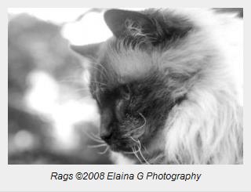
So I compiled some questions and e-mailed them to Tim. To make it as accurate as possible for Internet posting, we did the entire interview through e-mail. Here’s what Rags said to Tim:
1. Does Rags come and visit me now?
*** Not as much now as in the early days. He said that he is always there when you need him. He likes to help you with your work, especially when you need to make a tough decision.
How will I know when he is visiting, if he indeed is?
*** He said you would feel his warmth all around you. You will also have an overall since of knowing when you are thinking of him. He knows you have been thinking about him recently.
2. Does he visit Trigg, Charlie, Caymus or Murphy? Has he talked to Trigg and Charlie about me?
*** Less now than in the early days. However, he did leave his teachings behind for the animals after he left. These are likely to be characteristics and habits he had (both good and not so good) that the other animals are now exhibiting.
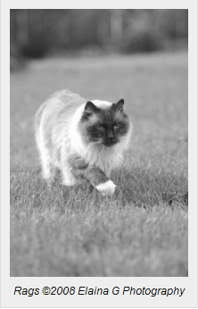
What role did he play in my life?
*** He was there to help you grow into the person you are today. He was more than a constant companion, he was a kindred spirit.
3. Has he come back? Where is he?
*** He has not chosen to come back into body at this time. He seems to be enjoying his time in universal energy and is teaching others. He has a strong energy and teaches others how to be strong and support those around you.
4. Will he come back to me?
*** He has not made any decisions yet. I do not believe he is one of the kittens you are considering. However, he will likely visit and teach any new additions to your furry family.
——————
Tim can be reached through his website: www.wagging-tales.com or via phone at 404-422-6355. Tim is located in Cumming, GA.

